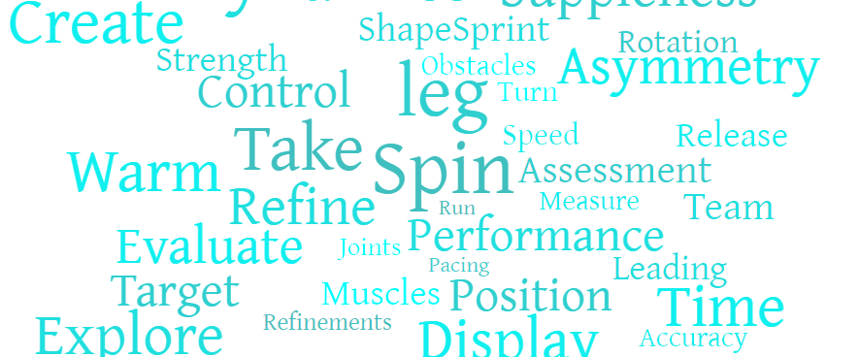
PE
At
Kingswood Primary Academy
Kingswood Primary Academy Curriculum Intent
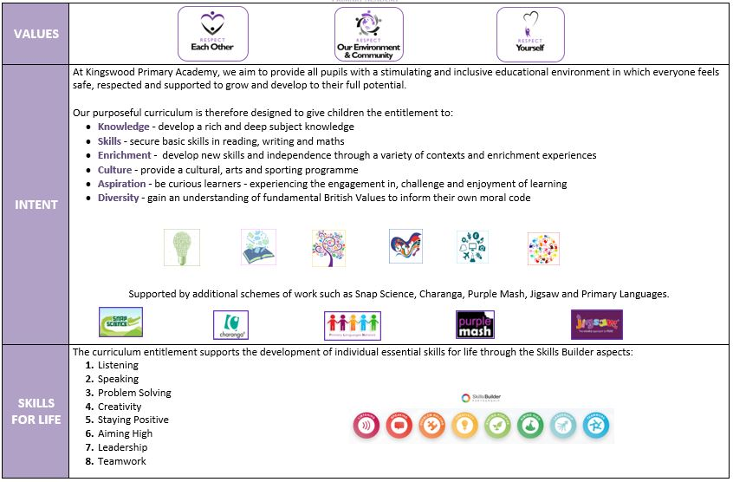
Overview
At Kingswood Primary Academy we recognise the role that Physical Education has to play in promoting a long-term healthy lifestyle which is both enjoyable and fulfilling. We aim to provide a high-quality physical education curriculum in which pupils are physically active for a sustained period of time. We aim to inspire all of our pupils to succeed and excel in competitive sport and other physically demanding activities. Through our physical education culture we aim to enhance academic achievement, as well as the health and well-being of our pupils. In turn, we believe this will have a positive impact on progress in reading, writing and maths.
We want to provide opportunities for our pupils to become confident and physically literate in a broad range of activities, in a way which supports their wellbeing. In addition to this, we aim to provide opportunities for children to compete in sport and other activities in order to build resilience and embed values such as teamwork, fairness and respect.
Intent
It is our intent at Kingswood to teach children life skills that will positively impact on their future. We aim to deliver high-quality Physical Education, that will inspire all children to succeed in physical activities later in life. We aim for all children to be physically active for sustained periods of time, on a daily basis and be able to make informed decisions to lead healthy and active lives. We want to teach children how to co-operate and collaborate with others as part of a team, understanding fairness and equity of play, resilience in competing and the spirit of the games. We want to expose children to a variety of sporting events, both within our curriculum, as well as at competition level.

At Kingswood, the life skills of teamwork and leadership are as important as the practical skills of balance, coordination and tactics to name a few.

However, it is our intent that children’s mental health and well-being is provided for as well as their physical health, so at KPA we include units of work, such as yoga at the end of both key stages within our curriculum map. Swimming is an important life skill, so our KS2 children swim throughout different times of the year. We aspire for all children to leave the academy being able to swim at least 25 metres and being able to self-rescue.

Implementation
Pupils participate twice weekly in high quality PE and sporting activities, with additional daily access to other active lessons, our wonderful mile a day track and support from lunchtime active playgrounds. All classes participate in 5-a-day, cosmic yoga, go noodle or BBC Super Movers fitness videos on a daily basis to help students meet the 30 minutes of physical activity within the school day.

Our PE curriculum incorporates a variety of sports to ensure all children develop the confidence, tolerance and the appreciation of lots of sports. This is enhanced by visits from athletes to inspire the children to participate. We provide opportunities for all children to engage in extra-curricular activities during and after school, in addition to competitive sporting events run throughout the year. This is an inclusive approach which endeavours to encourage not only physical development but also, well-being, attending both highly competitive sporting events and also festivals that celebrate participation or OAA events focusing on other skills.

We support those children who need additional guidance in making healthy choices, then provide them with routes into our own after school sporting provision or community sport clubs.
Impact
At Kingswood Primary Academy, our curriculum aims to improve the wellbeing and physical fitness of all children, not only through the sporting skills taught, but through the underpinning values and disciplines that PE promotes. We ensure that our PE curriculum is progressive and allows children to develop fundamental skills and apply them to a variety of fun sports and activities that the children are interested and inspired to take part in. Year 6 pupils leave school with the skills to self-rescue in the water and swim 25 metres competently.

Within our lessons, children are taught about self-discipline and that to be successful you need to take ownership and responsibility of your own health and fitness. All children are provided with the skills and given opportunities to demonstrate improvements to achieve their personal best. Our pupils are physically active, not just within the PE lesson, but throughout the day - this has positive implications on their learning inside the classroom. Children understand how to lead a healthy lifestyle and understand the importance of exercise. We hope children enjoy PE and develop a love of sport, and physical activity, that they pursue outside in future life.

Children are encouraged to achieve and shine by taking part in intra-sport competitions. Children of all abilities will take part in competitive sporting activities at the end of some units of work once a term. The skills they have acquired will be used to compete as part of a team in competitions.

Curriculum Design

Year | Key Learning Sequence |  | PE Focus and Connections
EYFS | First PE, Movement to Music  Enjoy a ball, FMS  Football, Movement to Music  Multi-skills, Dance  Athletic Skills, Dance  Tennis, Dance |  | - Motor competence  - Healthy participation
Y1 | OAA, Football  Gymnastics, Multi-skills  Ball Games, Dance  Balls Skills, Dance  Yoga, Athletics skills  Ball Skills, Kwik Cricket |  | - Motor competence  - Healthy participation
Y2 | OAA, Football  Gymnastics, Fitness  Ball Games, Dance  Dance, Indoor Athletics  Yoga, Athletics  Tennis, Kwik Cricket |  | - Motor competence  - Healthy participation
Y3 | OAA, Football  Gymnastics, Fitness Circuits  Handball, Dance  Multi-skills, Dance  Athletics, Swimming  Tennis, Kwik Cricket |  | - Rules, strategies and tactics  - Healthy participation
Y4 | OAA, Tag Rugby  Gymnastics, Fitness Circuits  Basketball, Swimming  Indoor Athletics, Dance  Athletics, Tennis  Golf, Rounders |  | - Rules, strategies and tactics  - Healthy participation
Y5 | OAA, Tag Rugby  Gymnastics, Fitness Circuits  Multi-skills, Basketball  Swimming, Dance  Athletics, Tennis  Golf, Rounders |  | - Rules, strategies and tactics  - Healthy participation
Y6 | OAA, Tag Rugby  Gymnastics, Fitness Circuits  Leadership, Basketball  Indoor Athletics, Dance  Athletics, Tennis  Dodgeball, Rounders  Top-up swimming |  | - Rules, strategies and tactics  - Healthy participation
SEND – Strategies for supporting access  - Break down learning – now/then  - Adult support – start off then independent (where possible)  - Specific simple instructions  - Re-capping within lessons for all or groups of pupils  - Mixed ability groups |  | Enrichment  Children participate in workshops covering a variety of sports throughout the year, for example; outdoor and adventure, dance, football and skipping, providing the children with an opportunity to develop, improve their fitness and to try something new. For these workshops we have had a range of visitors into school including Mad2Perform and Olympians from the Mintridge Project.  All children are offered the chance to compete for the school in local competitions.

Subject Leadership and Development
Subject Strengths  - Knowledge of subject gaps and how these have been addressed.  - Staff knowledge of their curriculum – progression and sequence  - Pupil enjoyment of PE  - Range of experiences provided.  - Collaborative approach to the planning – LTP/MTP with all staff  - Clear sequence of learning in planning | Areas to Develop  - Continue to develop lesson activities for effectiveness  - Continue to access specialist training from external providers to ensure the best and most current practice.  - Continue to develop academy website  - Continue to develop assessment
Monitoring  - T1 Focus – Planning development  - T2 Focus – Lesson Visits and Pupil Voice  - T3 Focus – Staff voice | CPD  - Stuart Allison Consultancy  - Unmatched Coaching

