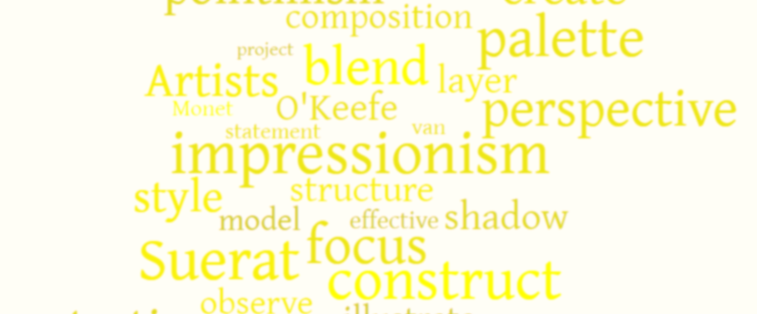
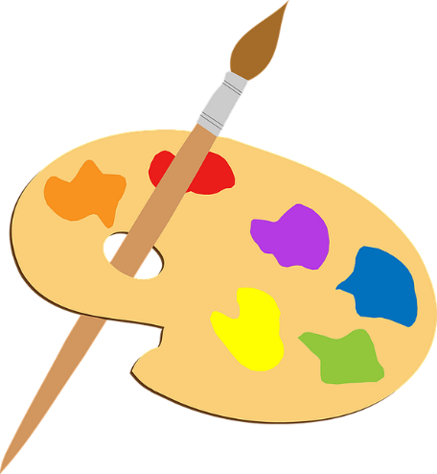
Art
At
Kingswood Primary Academy
Kingswood Primary Academy Curriculum Intent
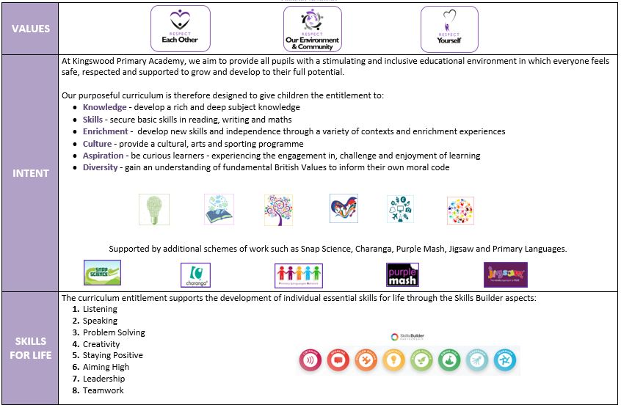
Overview
Art, craft and design embody some of the highest forms of human creativity. A high-quality art and design education should engage, inspire and challenge pupils, equipping them with the knowledge and skills to experiment, invent and create their own works of art, craft and design. As pupils progress, they should be able to think critically and develop a more rigorous understanding of art and design. They should also know how art and design both reflect and shape our diverse history, and contribute to the culture, creativity and wealth of our nation.

Art activities give children a much-needed chance to express their ideas, build on their observational skills, gain confidence, promote feelings of self-worth and develop their creativity, imagination and aspiration, as well as offering them time to relax.

We believe that Art & Design sparks creativity across the curriculum, encouraging young people to be inquisitive, disciplined and determined.
Intent
At Kingswood Primary Academy we aim to inspire pupils to develop their confidence to experiment and aspire to invent their own works of art. We use and adapt the Kapow Primary Art & Design curriculum to give pupils every opportunity to develop their knowledge and skills, nurture their talent and interests, express their ideas and thoughts about the diverse and rich cultures of the world, as well as learning about the rich heritage and culture of the British Isles and beyond.
Implementation
There are five strands that run throughout our Art & Design curriculum:
- Making: painting, drawing, printing, creating 2 & 3D art and crafting
- Generating ideas and taking inspiration from a range of artists and crafts people
- Formal elements: colour, form, line, pattern, shape, texture and tone
- Knowledge of artists' work and techniques
- Evaluating: critiquing their own work and that of others

These strands are revisited in every unit. In the Art and design skills and the Formal elements of art units, pupils have the opportunity to learn and practice skills discretely. The knowledge and skills from these units are then applied throughout other units in the scheme. Key skills are revisited again and again with increasing complexity in a spiral curriculum model. The allows pupils to revise and build on their previous learning.

The curriculum develops pupil’s knowledge and understanding of key artists and art movements through Every picture tells a story units and links to artists through practical work. Each unit fully scaffolds and supports essential and age-appropriate sequenced learning and is flexible enough to be adapted to form cross-curricular links. Creativity and independent outcomes are robustly embedded in units, supporting pupils in learning how to make their own creative choices and decisions, so that their art outcomes, whilst still being knowledge-rich, are unique to the pupil and personal.

Impact
The Art & Design curriculum is designed in such a way that children are involved in the evaluation, dialogue and decision making about the quality of their outcomes and the improvements they need to make. By taking part in regular discussions and decision-making processes, children will not only know facts and key information about art, but they will be able to talk confidently about their own learning journey, have higher metacognitive skills and have a growing understanding of how to improve. Children should leave primary school equipped with a range of techniques and the confidence and creativity to form a strong foundation for their Art and Design leaning at Key Stage 3 and beyond.

We expect that children will:
- Produce creative work, exploring and r4ecording their ideas and experiences
- Be proficient in drawing, painting, sculpture and other art, craft and design techniques.
- Evaluate and analyse creative works using subject-specific language.
- Know about great artists and the historical and cultural development of their art.
- Meet the end of key stage expectations outlined in the NC for Art and Design.

Curriculum Design

Year | Key Learning Sequence |  | Art & Design Focus and Connections
EYFS | Clay creatures  Leaf pictures  Patterns and colours  Penguins and polar bears using different media and techniques  African patterns, prints and masks  Butterfly pictures  Clay minibeasts |  | Physical Development - Hold a pencil effectively in preparation for fluent writing - using  the tripod grip in almost all cases.  Use a range of small tools, including scissors, paintbrushes and cutlery.  Begin to show accuracy and care when drawing.  Expressive Arts and Design - Safely use and explore a variety of materials, tools and techniques, experimenting with colour, design, texture, form and function.  Share their creations, explaining the process they have used.
Y1 | Formal elements of art  Art and design skills  Landscapes |  | - Exploring three of the formal elements of art: shape, line and colour, children will mix and paint with secondary colours; use circles to create abstract compositions and work collaboratively to create art inspired by water.  - Learning two different printing techniques, using 2D shapes to explore a variety of media, mixing different shades of one colour and discussing the work of artist Louis Wain.  - Learning about composition and working with different art materials to create texture. Based on the theme of the seaside.
Y2 | Formal elements of art  Art and design skills  Human Form |  | - Exploring the formal elements of art: pattern, texture and tone; children create printed patterns using everyday objects; take rubbings using different media and learn how to make their drawings three dimensional.  - Replicating the recognisable crockery of Clarice Cliff, exploring tone through shading, developing weaving skills, the manipulation of clay and experimenting with brush strokes.  - Creating sculpture, pop art and learning how to draw facial features to portray different emotions, all through the topic of comic superheroes and inspired by the works of Roy Lichtenstein.
Y3 | Formal elements of art  Art and design skills  Prehistoric Art |  | - Completing a drawing from observation, learning the difference between a tint and a shade and creating versions of a cartoon drawn by a famous illustrator.  - Experimenting with charcoal, berries, leaves, homemade paints and more, children get a sense of what it was like to create art thousands of years ago and why these pieces were created.  - Exploring two of the formal elements of art: shape and tone; children find shapes in everyday objects; use shapes as guidelines to draw accurately from observation and create form and shape using wire.
Y4 | Formal elements of art  Art and design skills  Sculpture |  | - Exploring and using unusual objects to create 3D works of art. Creating drums and maracas from recycled materials and looking at different techniques, such as wax resist and collages to create different effects.  - Exploring two of the formal elements of art: texture and pattern; developing a range of mark-making techniques, making and using their own textured stamps for printing and draw a ‘flip’ pattern.  - Creating an optical illusion print, replicating a plate in the famous willow pattern, carving sculptures out of soap, drawing a collection of still life objects, painting and mixing colours and learning about the role of a ‘curator’.
Y5 | Formal elements of art  Art and design skills  Every picture tells a story |  | - Analysing the intentions of artist Banksy; making ink symmetry prints inspired by psychologist Rorschach; telling a story using emojis; using drama to recreate a poignant war scene and creating art inspired by the ceramic work of Magdalene Odundo  - Designing an invention, expanding on an observational drawing, using a poem to create a portrait, painting an enlarged section of a drawn collage and learning how to ‘think’ like an artist.  - Learning how to draw from observation, creating a print and drawing from different perspectives. Learning about the role of an architect and considering why houses look the way they do and if there is scope to change and improve them.
Y6 | Making my voice heard  Art and design skills  Still Life |  | - Looking at the works of artists Picasso and Kollwitz and, through the mediums of graffiti, drawing, painting and sculpture, creating their own artworks that speak to the viewer.  - Design, drawing, craft, painting and art appreciation; working as a group to design a hat, creating zentangle patterns and subsequent prints, painting in the style of impressionist painters and exploring the piece ‘Nighthawks’ by Edward Hopper.  - Creating a variety of pieces influenced by different artists using a range of mediums and using charcoal, erasers and paint to depict a composition of special objects.
SEND – Strategies for supporting access  - Break down learning – now/then  - Adult support – start off then independent (where possible)  - Images to support  - Specific simple instructions  - Differentiation – scaffold  - Re-capping within lessons for all or groups of pupils  - Mixed ability groups  - Definitions – revisit |  | Enrichment  Educational visits are another opportunity for Art to take place outside of the classroom.  - Paula Boulton – local artist  - Visits to Art Gallery – Rockingham Castle  - Lemonpop Academy  - Visiting illustrators (pre-Covid)  - Discovery Art Day (pre-Covid)

Subject Leadership and Development
Subject Strengths  - Pupil enjoyment of Art & Design  - Collaborative approach to the planning – LTP/MTP with all staff  - Clear sequence of learning in planning  - Strong links made to Geography and History – giving learning purpose and clarity. | Areas to Develop  - Continue to develop teacher confidence and skills  - Continue to access specialist training from external providers to ensure the best and most current practise.  - Continue to develop enrichment activities to the level pre-Covid
Monitoring  - T1 Focus – Lesson drop ins  - T2 Focus – Pupil voice  - T3 Focus – Sketchbooks | CPD  - Kapow online CPD for every lesson/skill

